SVM Injury Reporting

EMPLOYEE WORK RELATED INJURY AND ILLNESS REPORTING:
Employee work-related injuries or illnesses must be immediately reported to supervisor and this protocol must be followed.

For Medical Emergency: Call 9-1-1 or go to Sutter Davis Hospital Emergency Room

1. Supervisor (or next responsible person) is to accompany the employee to Sutter ER – Employees need to notify supervisors of Extended Hospitalization and Return to Work restrictions.
2. For work-related fatalities and serious injuries (or even if severity is undetermined) the Supervisor should contact (WITHIN 8 HOURS OF INJURY):
- EH&S at 530-752-1493 (During normal business hours)
- Police/Fire Dispatch Center at 530-752-1230 (Outside normal business hours)
- SVM Safety Officer at 530-219-3543 or VMTH Safety Officer at 530-219-0632
For instructions on Reporting Work-related Fatalities and Serious Injuries or Illnesses refer to SafetyNet #121.
- This is for hospitalization in excess of 24hrs, loss of member of body (ex: bone in finger even for wound treatment); serious degree of permanent disfigurement
3) Complete Employee's First Report Parts 1 & 2, and employee submits claim.
4) Supervisor is notified of a new claim in the system pending review.
5) Supervisor completes their investigation/statement sections and saves form.
6) Your Supervisor, Administrators and/or Group Members will complete rest of form.

Non-emergency, during regular work hours Mon-Fri (8am – 5pm):

1) Call Occupational Health Services at 530-752-6051 to notify them the employee is enroute
2) The Occupational Health Clinic is located in the Cowell Building
3) Complete Employee's First Report Parts 1 & 2, and employee submits claim.
4) Supervisor is notified of a new claim in the system pending review.
5) Supervisor completes their investigation/statement sections and saves form.
6) Your Supervisor, Administrators and/or Group Members will complete rest of form.

Non-emergency, outside of normal business hours (Evenings and Weekends):

1) Go to Sutter Urgent Care (weekdays & weekends) Davis Urgent Care (weekends) or the closest medical treatment facility if medical treatment is needed. Sutter Urgent Care Authorization Form
2) Complete Employee's First Report Parts 1 & 2, and employee submits claim.
3) Supervisor is notified of a new claim in the system pending review.
4) Supervisor completes their investigation/statement sections and saves form.
4) Your Supervisor, Administrators and/or Group Members will complete rest of form.

For Workers' Compensation Related Questions:
Kim Sieg (campus): klsieg@ucdavis.edu, (530) 752-7243, FAX (530) 752-3439

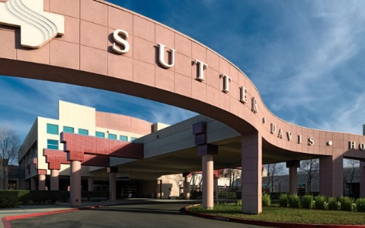
Sutter Davis Hospital – ER
2000 Sutter Place
(530)757-5111
After-hours, weekends, holidays

Occupational Health
Cowell Hall – California Ave
(530)752-6051
Mon, Tues, Thurs, Fri 8am-5pm
Wed 9am-5pm
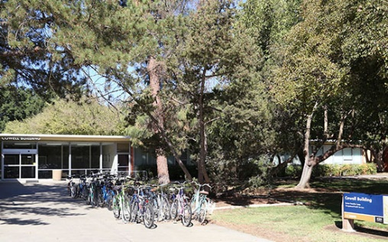

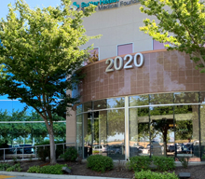
Sutter Urgent Care
2020 Sutter Place #101
(530)750-5830
Open Evenings 5:30pm-9pm
and Weekends 10:00am-5:30pm

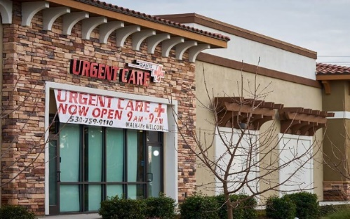
Davis Urgent Care
4515 Fermi Place #105
(530)759-9110
Weekends 8am-5pm

